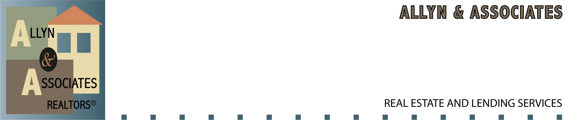

Date: _____________

CUSTOMER FEE AGREEMENT FOR ALLYN & ASSOCIATES for NON-RESPA
COMMERCIAL/BUSINESS LOANS.

I understand that you are seeking mortgage financing on my behalf for the refinance or purchase of our property located at (Fill address or APN here):____________

______________________________________________________________________

I understand and agree that as compensation for your professional mortgage services, my fee is ___% of the loan amount, plus $695 for the file-processing fee.

I hereby, irrevocably direct the escrow company to pay such an amount to you at closing, either out of separate funds that I have deposited or out of loan proceeds. Fees due to Allyn and Associates only upon closing of loan.

I further acknowledge that this fee to Allyn and Associates is not imposed or collected by or paid to the lender. Lenders fees will be disclosed at the time of loan approval.

I understand that, while the lender is not requiring me to pay such fees, under federal law and under most circumstances, the above fee to Allyn and Associates will be considered part of the finance charge for such financing.

X_____________________________________________________DATED__________

X_____________________________________________________DATED__________

Broker/Loan Officer ______________________________________DATED_________

351 Hitchcock Way, Suite B130, Santa Barbara, CA 93105, 805-895-5101

